|  |  |  |  |  |
| --- | --- | --- | --- | --- |
| **Reference** | | | | |
| Reference | Version : | Language: | Application date : | Date of review : |
|  | V0.1 |  | 2023/12/04 | AAAA/MM/JJ |
| State : | Sending function : | | Sending department : | |
|  |  | |  | |

|  |  |  |  |  |  |
| --- | --- | --- | --- | --- | --- |
| **Modification history** | | | | | |
| Ver. | Date | Modified by | Checked by | Approved by | Revision object |
| V0.1 | 2023/12/04 |  |  |  |  |
|  |  |  |  |  |  |
|  |  |  |  |  |  |
|  |  |  |  |  |  |

|  |  |
| --- | --- |
| **Object** | |
| Object: | Customizing guide Salesforce |
| Attachment process: |  |
| Recipient: |  |

|  |  |  |  |
| --- | --- | --- | --- |
| **Signatories** | | | |
|  | Written by | Checked by | Approved by |
| Name | Dyhia AMER |  |  |
| Function |  |  |  |
| Date | 2023/12/04 | AAAA/MM/JJ | AAAA/MM/JJ |
| Sign |  |  |  |

|  |  |  |  |
| --- | --- | --- | --- |
| Accessibility | | | |
| ~~Public~~ | Internal | ~~Confidential~~ | ~~Restricted~~ |

Table of content

1. Create an application for Ekovya 3

2. Customize the ACCOUNT object 7

1. Type field customization 7

2. Set the Type picklist field to meet this request 7

3. Make it mandatory 9

4. Remove Parent Account field and Account site 9

5. Create a company email field 11

6. Rating Field tracking 12

7. Create a SIRET Field and remove SIC Code field 14

8. Create an account Currency field 15

9. Account Owner “Sales” 16

3. Customizing the CONTACT object 17

1. Account field must be mandatory 18

- Account field is a standard object. 18

- Go to the Contact Page Layout to set this specific field into Required. Object Manager > Contact > Page Layout > Contact Page Layout > Fields. 18

- Account Name Field is set to « Required ». 18

2. Remove some standard fields 19

3. Change the type of the Languages Field into a picklist field 20

4. Change the type of the value into Picklist 20

4. Customizing the LEAD object 21

1. Remove Title field 21

2. Add the company email 22

3. Create a new picklist value 23

6. Sales Cloud implementation 24

1. Create thank you page in Wordpress 24

2. Create Web-to-Lead form 26

**Salesforce is the most widely used customer relationship management platform in the world. It is used to improve collaboration between teams and to better understand customer expectations.**

# 1. Create an application for Ekovya

Ekovya can centralize the information needed in an application customized in order to manage its business.

* To do so, we created Ekovya application through **Setup** button.

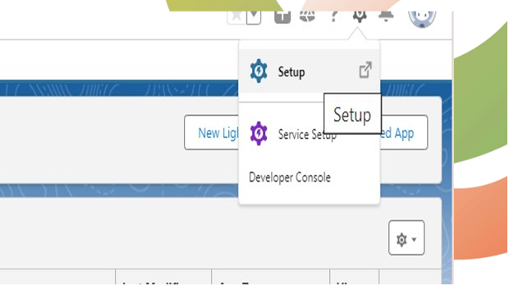

* From the **quick finder**: enter App Manager and then select **App Managers**.

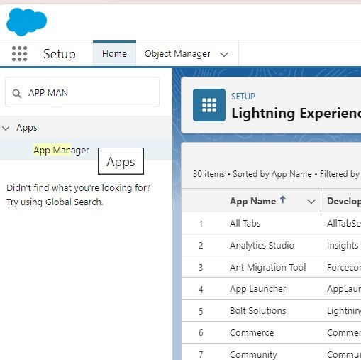

* Click **new Lightning App** to walk through the **Lightning App Wizard**.

* Fill the **fields** required to customize the application and click **next**.

* Select the options needed click **next**.

* Click **next** again

* Add the **items** needed and click **next**.

* Select **profiles** to assign to users.
* Use the arrow logo to move the items
* Click **Save and Finish** to exit the wizard.

# 2. Customize the ACCOUNT object

## 1. Type field customization

* From **Setup**, Select the **Object Manager**, select **Account**, then **Fields & Relationships**, then select **Type** to customize the picklist of Ekovya's categories.



## 2. Set the Type picklist field to meet this request

* **Deactivate** the standard values
* Create new customised values with the categories described above and click **save**.

Ekovya classifies the Accounts according to these values

* A-Account
* B-Account
* C-Account

3. Make it mandatory

* **Field Type** is a standard field which is not required when creating a new account.
* Use the Account Page Layout to turn it into “Required”

## 4. Remove Parent Account field and Account site

* Parent account field and account site are standard fields that cannot be removed from the Page Layout.
* Click on “Account Site”

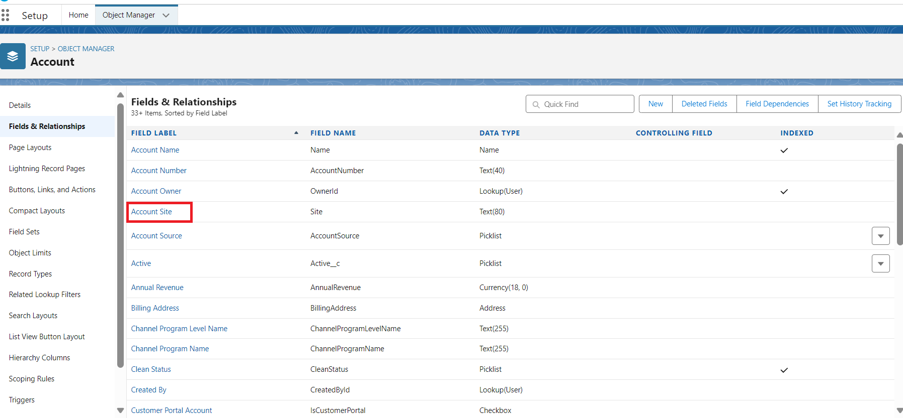

* To get them hidden from the user, set the **field-level security** and uncheck the visible checkbox for everyone.

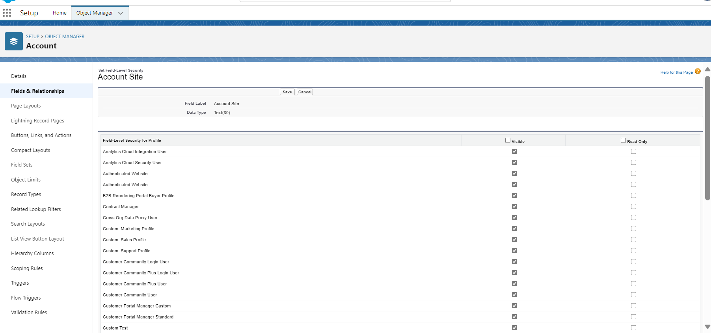

5. Create a company email field

* From **Setup**, Select the **Object Manager**, select **Account**, then **Fields & Relationships**, then **New**

* Create a new field with these settings
* Field type: email
* Field Label: Company Email
* Field Name
* Description

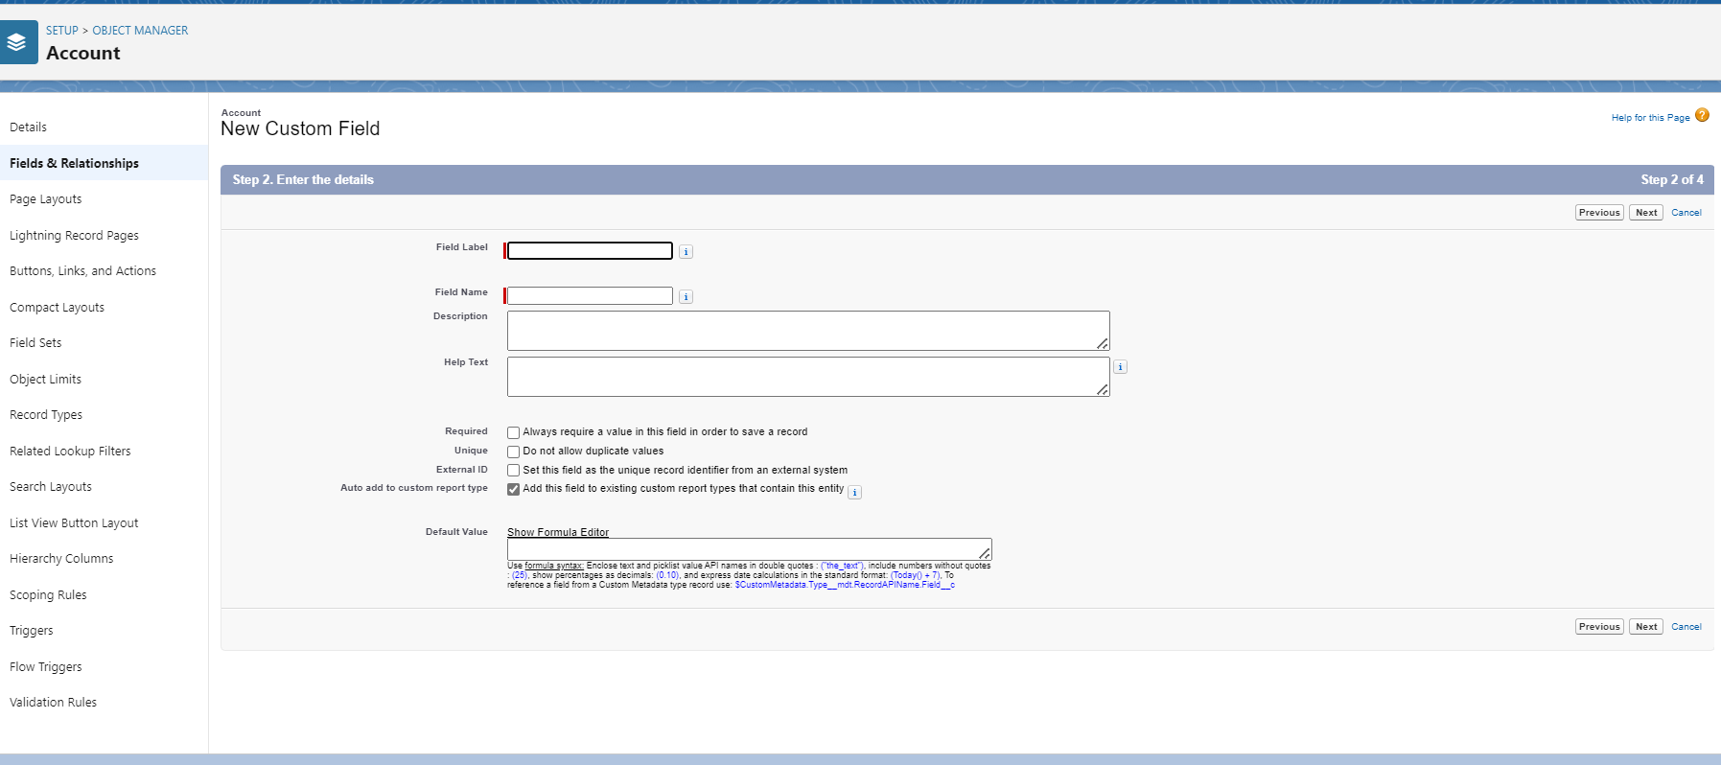

* Click **Next**, then **Next**, then **Save**

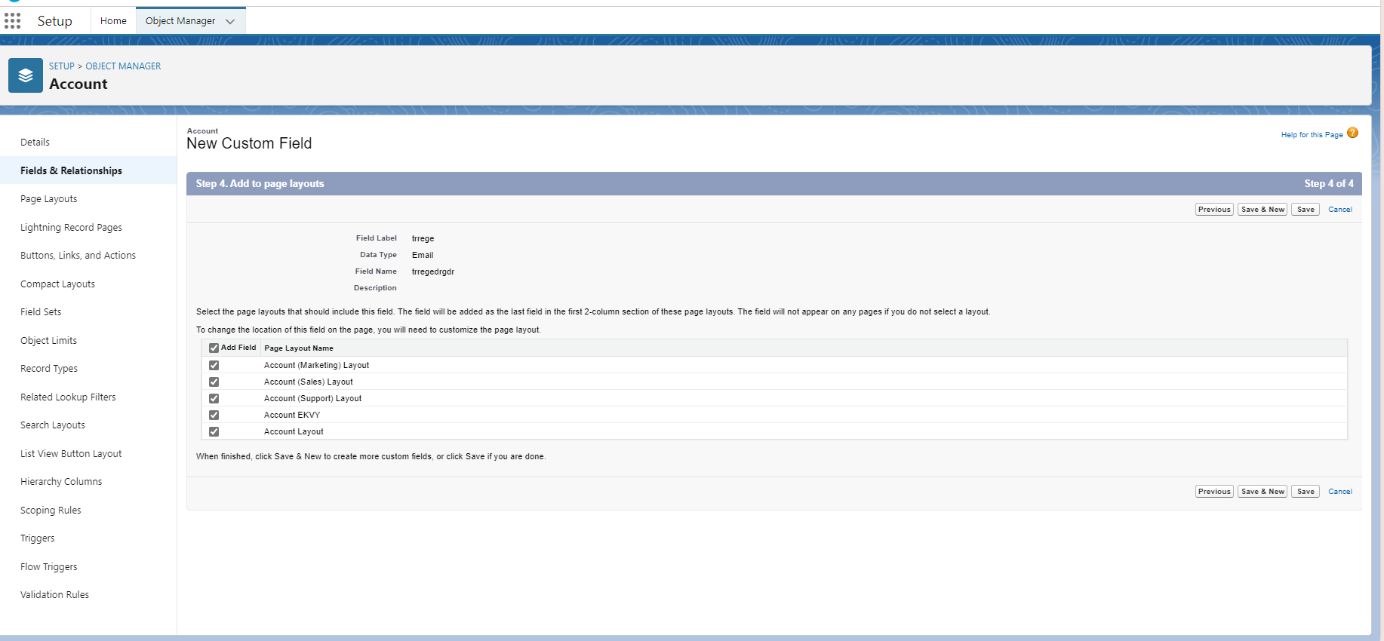

## 6. Rating Field tracking

* Track the Rating field so that users can have a follow-up of the different updates for this particular field.

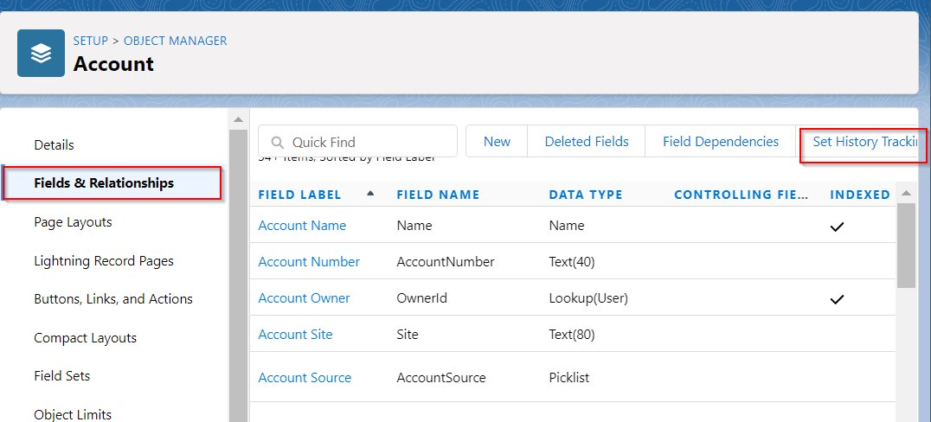

* Tracking in the Account History related list
* Enable Account History

* From the **Setup**, select the **Feed Tracking** in the **quick find box**
* Enable Tracking in the Chatter feed

## 7. Create a SIRET Field and remove SIC Code field

* Create **Siret Field** with these settings
* Field type: Number
* Field Label: Siret
* Length: 14

* Remove **SIC Code** field in the **Account Page Layout**
* **Object manager** > **Account** > **Page Layouts** > **Account Page Layout**

## 8. Create an account Currency field

* Create a new **field picklist** data type

* Enter the value and **save**

9. Account Owner “Sales”

* Create a group public called “Sales” for all the users
* Select **Public Groups** in the quick find box
* Select “New”

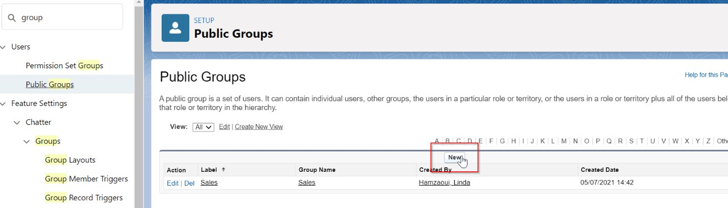

* Change the data owner of the account owner field

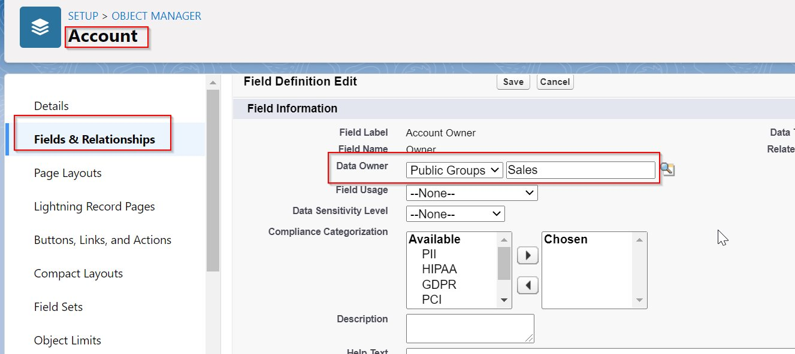

# 3. Customizing the CONTACT object

## 1. Account field must be mandatory

## Account field is a standard object.

## Go to the Contact Page Layout to set this specific field into Required. Object Manager > Contact > Page Layout > Contact Page Layout > Fields.

## Account Name Field is set to « Required ».

* Those fields are removed from the Page Layout:
* Home Phone
* Fax
* Assistant, Assistant Phone
* Other Address
* Level

* Add a field contact type
* Create a new field picklist data type
* Enter the value

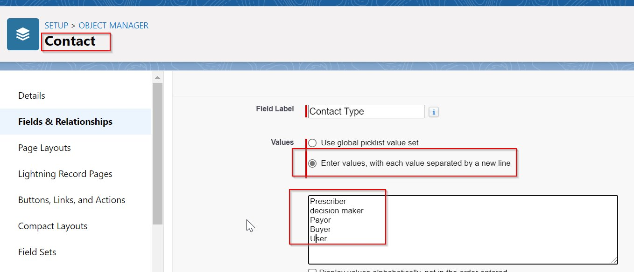

## 2. Remove some standard fields

* The currency field, home phone field, fax field, assistant field, assistant phone field, other address field, level field are standard fields that cannot be removed from the Page Layout.
* To get them hidden from the user, set the **field-level security** and uncheck the visible checkbox for everyone.

## 3. Change the type of the Languages Field into a picklist field

* Users could be able to choose between mutliple languages :
* English
* French
* Arabic
* Russian

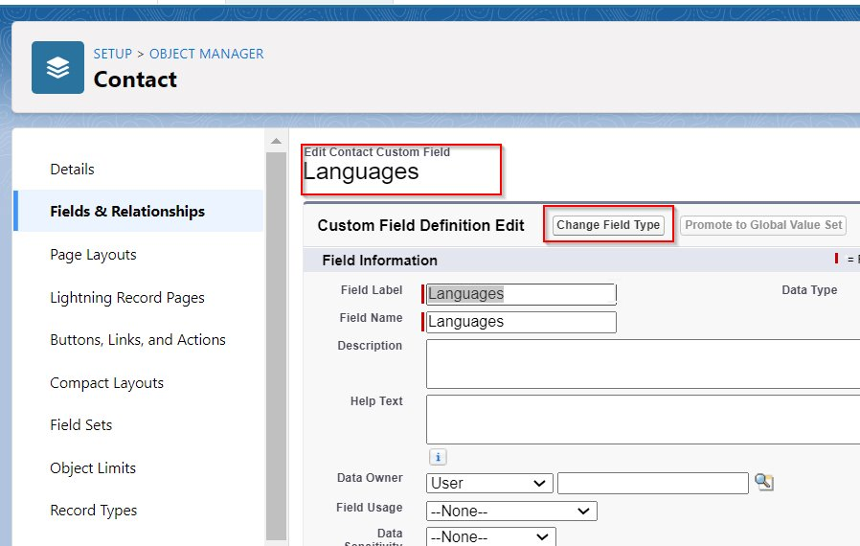

## 4. Change the type of the value into Picklist

* Set the values of the picklist with the languages listed above
* Choose **Enter values, with each value separated by a new line**
* Enter the values

# 4. Customizing the LEAD object

## 1. Remove Title field

Go to Object Manager > Lead > Page Layout > Lead Page Layout

Field removed from the Page Layout : Title

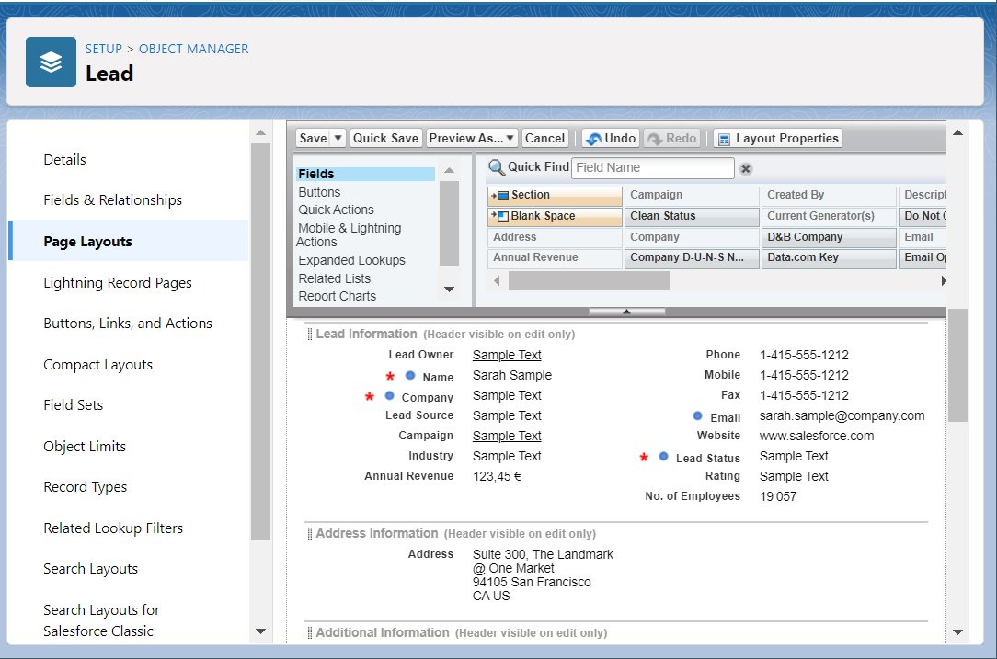

## 2. Add the company email

* Create a new field called « Lead Company E-mail »
* Field type : email
* Field Label: Lead Company E-mail
* Field-level security: visible for all profiles
* Add field to all page layouts

8. Set the Lead Process including the stage « Email Campaign Sent »

Edit the standard Lead Status field :

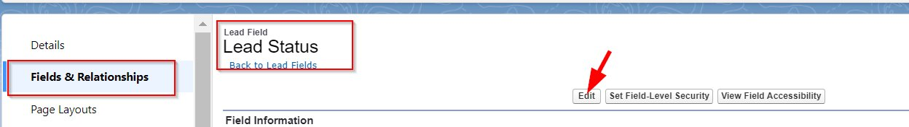

## 3. Create a new picklist value

* Label : Email Campaign Sent

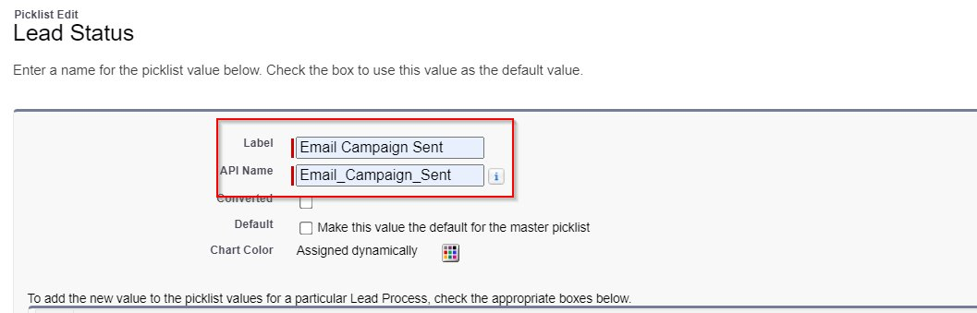

* Reorder the picklist value as below :
* Open – Not contacted
* Email Campaign Sent
* Working – Contacted
* Closed – Converted
* Closed – Not Converted

# 6. Sales Cloud implementation

**Set up a Web-to-lead form in Wordpress to gather leads.**

## 1. Create thank you page in Wordpress

* From the Home page in Wordpress, add a new page

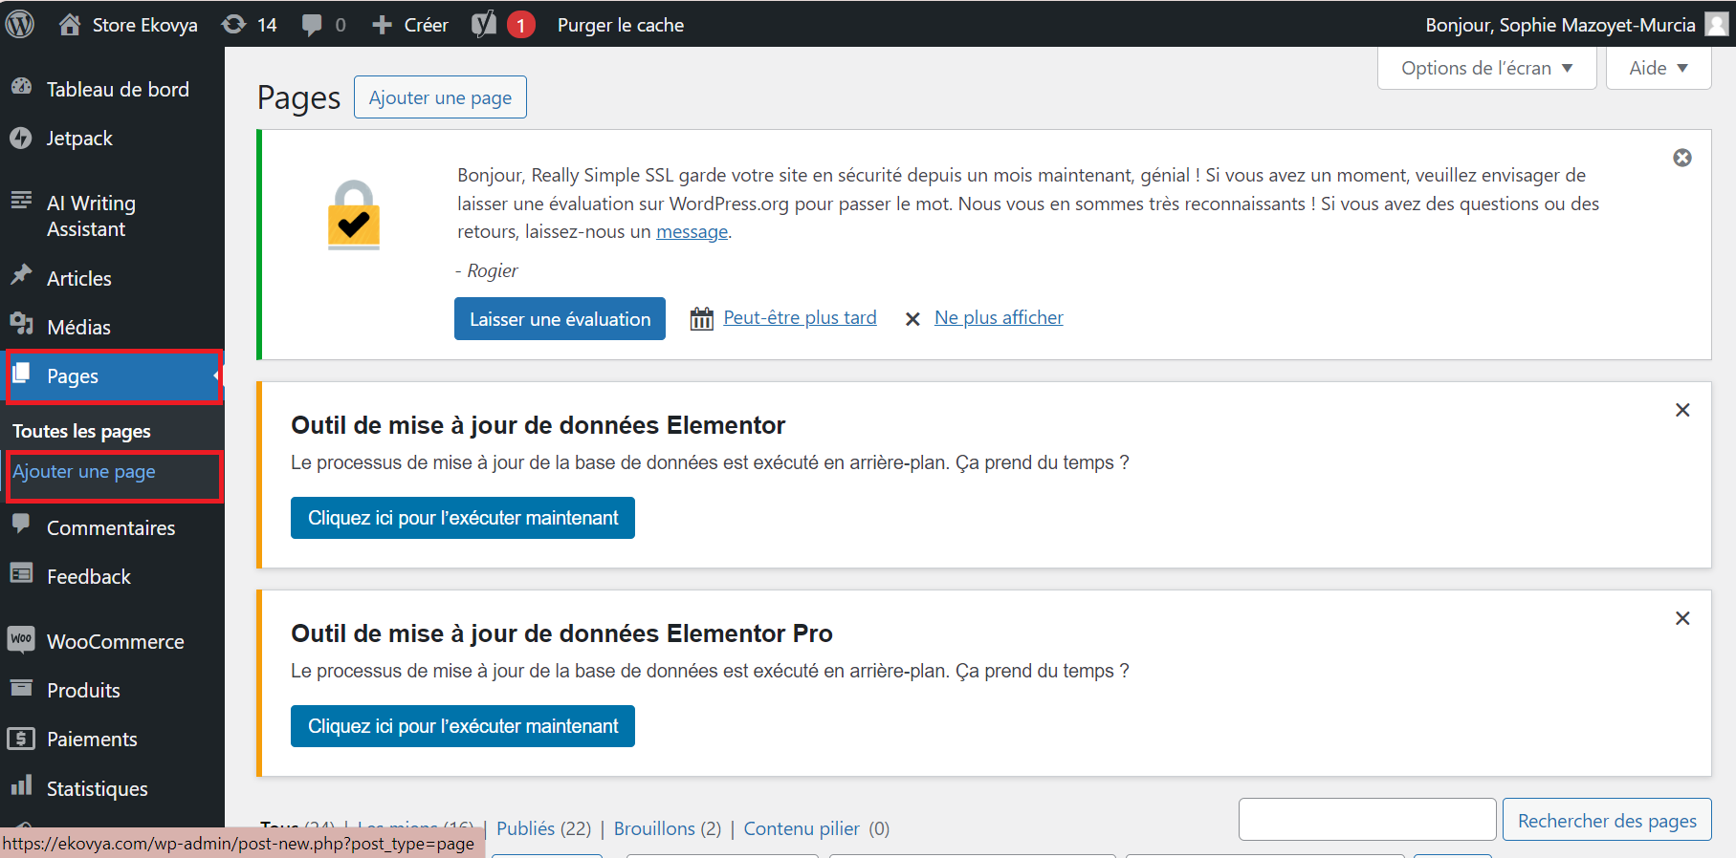

* Give a title to your thank you page

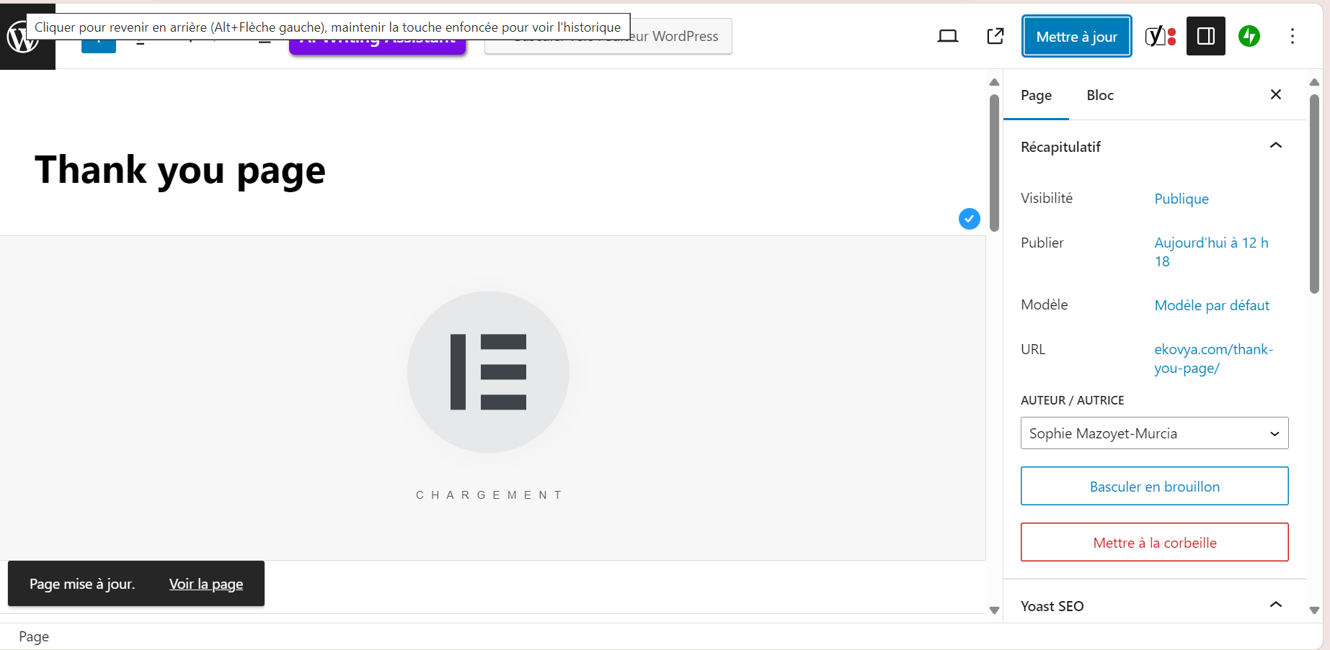

* Click on the Title in the Widgets function

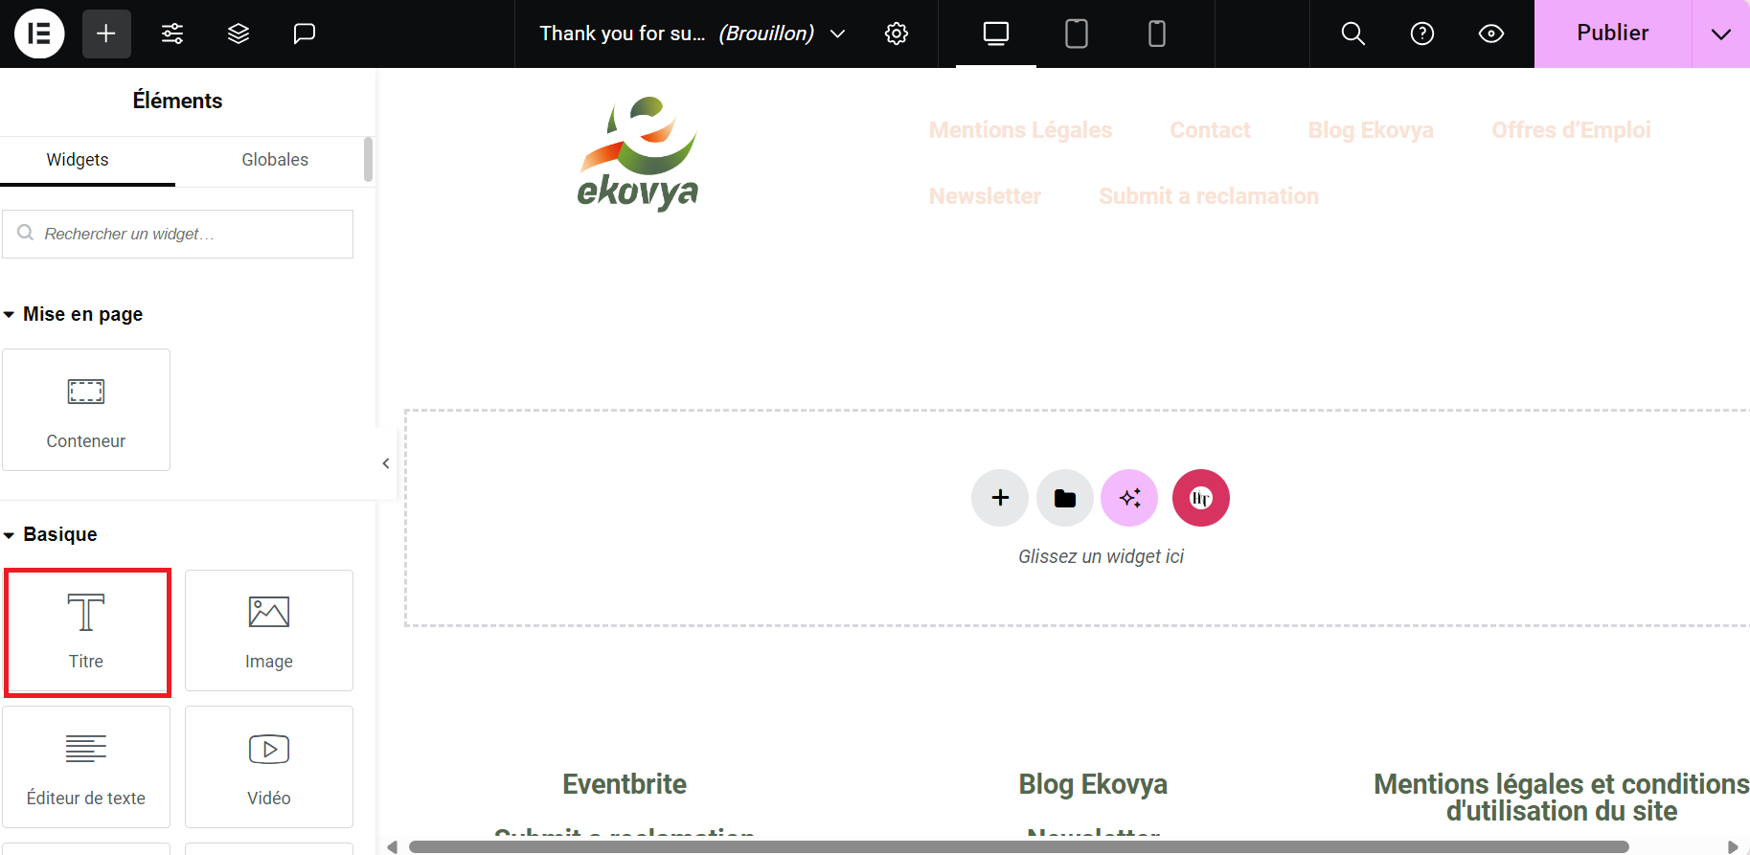

* Write your texte in the box

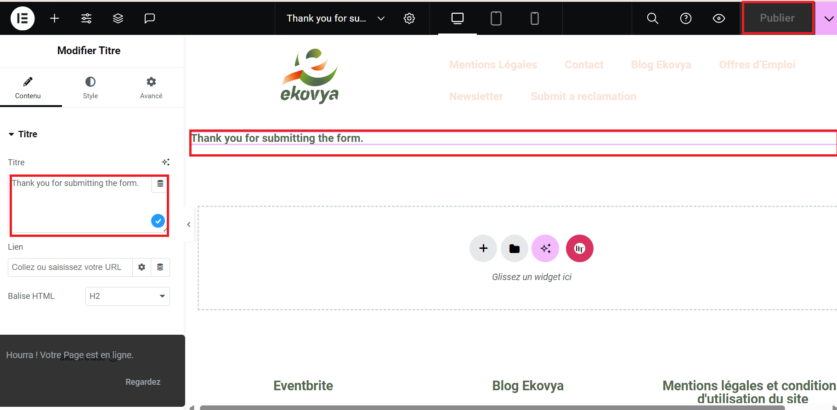

## 2. Create Web-to-Lead form

* Go to the **Setup** page, from the **quick finder** enter **Web-to-lead** and select **Web-to-lead**
* Click “Create Web-to-Lead Form
* Use the arrow logo to move the items that you need from the left to the right and enter the site address and click on generate

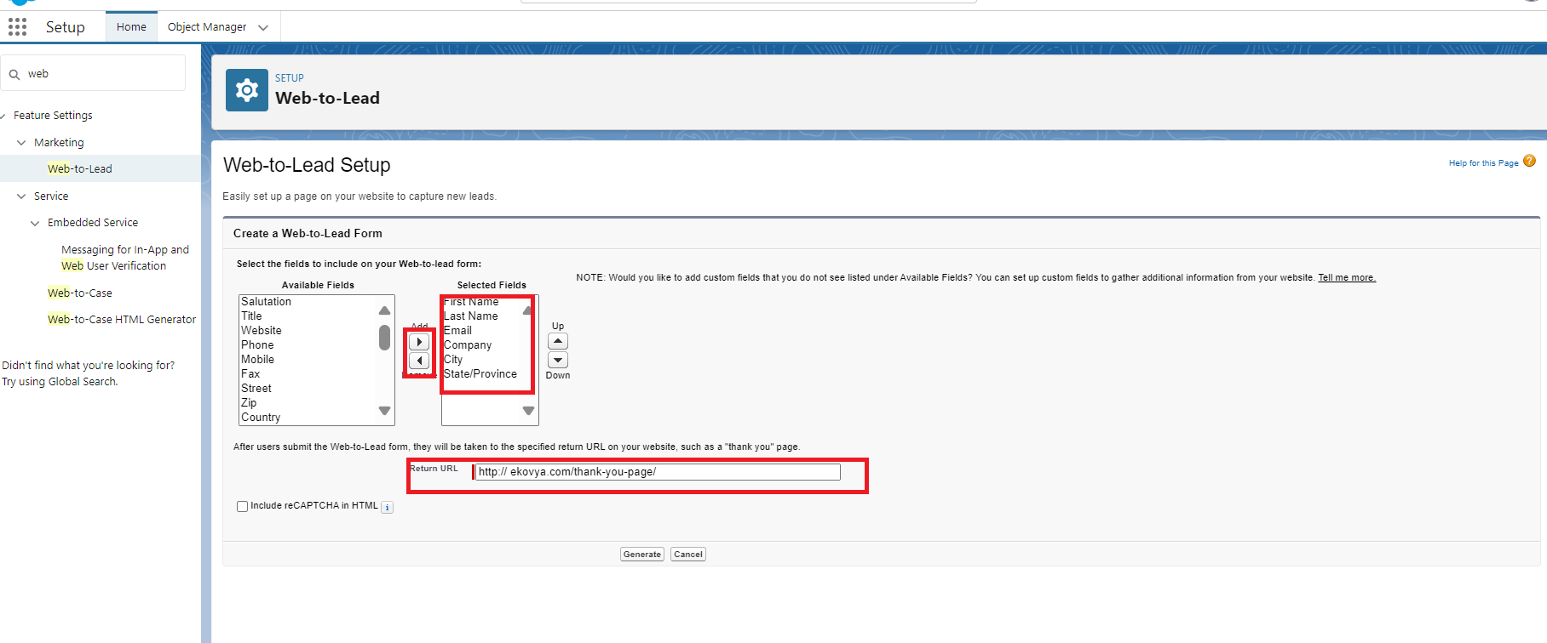

* When the sample HTML is created, copy and click on Finished

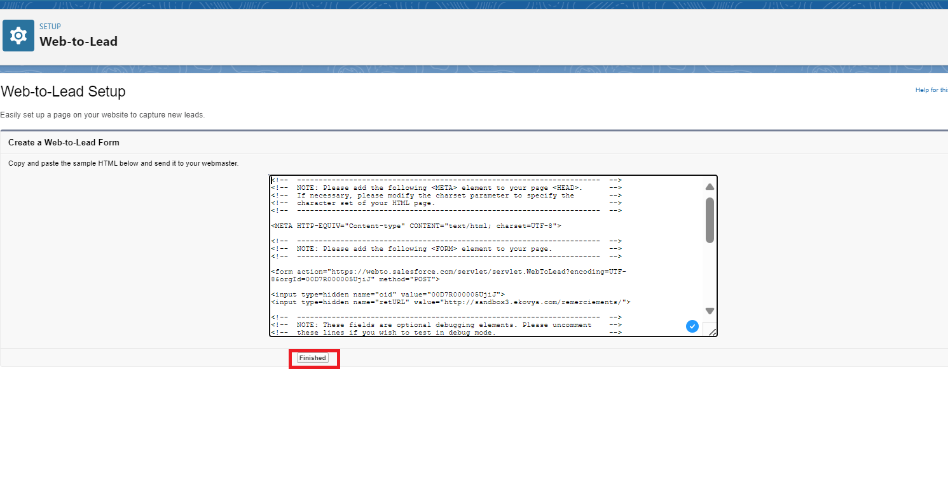

* Go to the Elementor click on Add a page



* Name the form

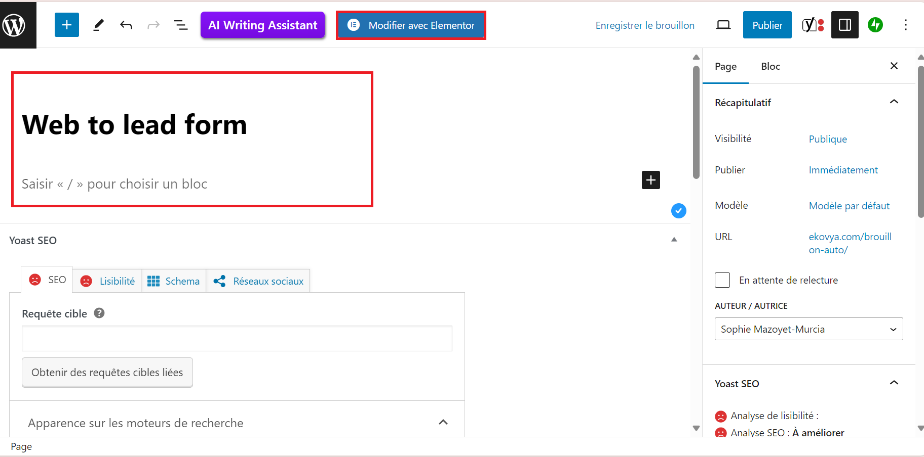

* From the quick finder enter HTML and then click + for add the HTML sample

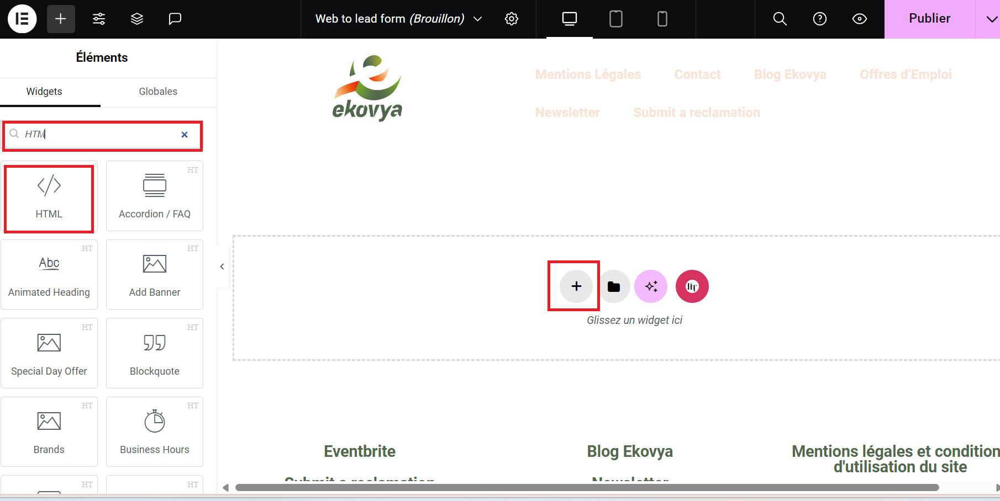

* Paste the HTML sample in the the Code HTML box

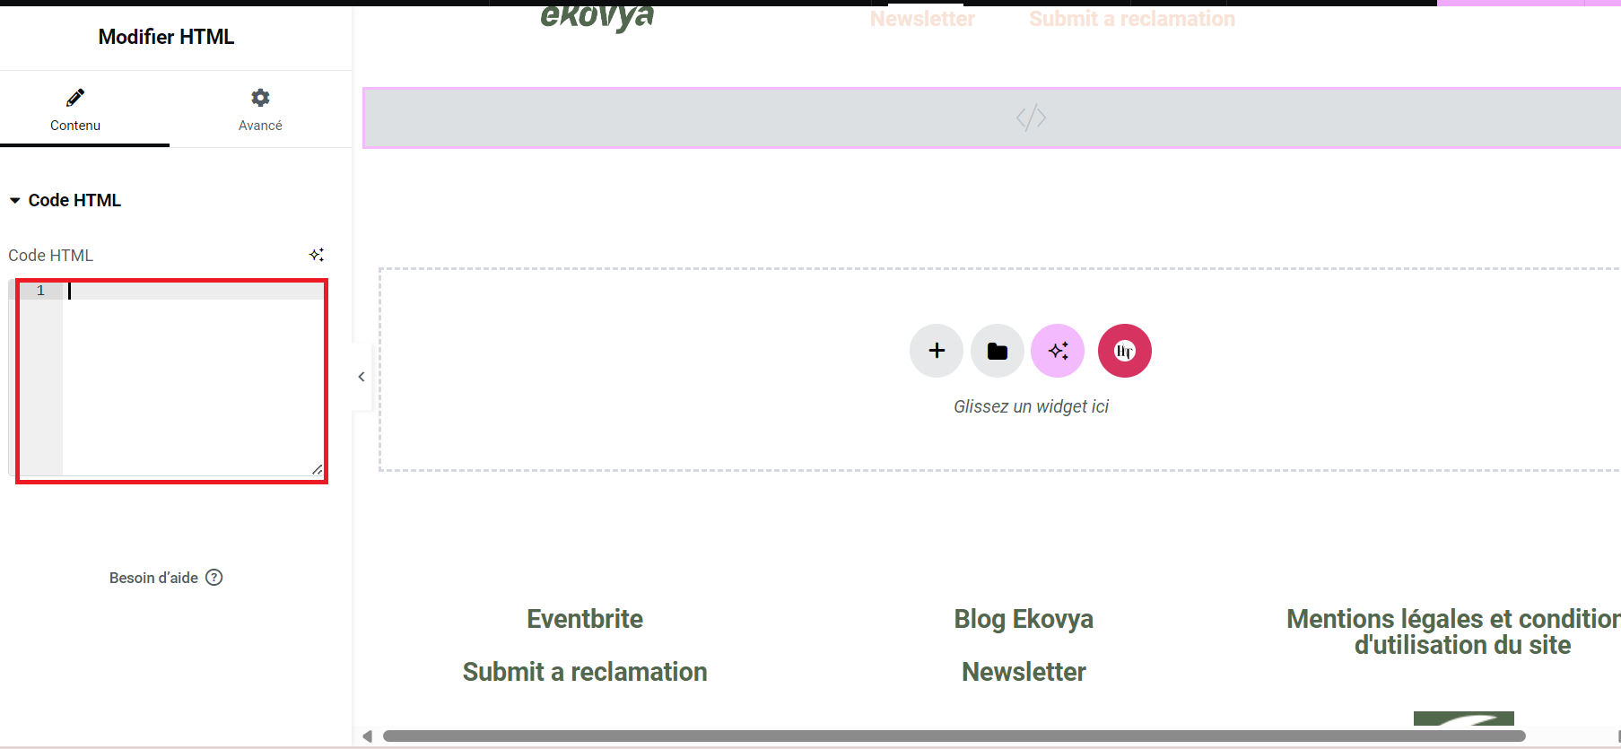

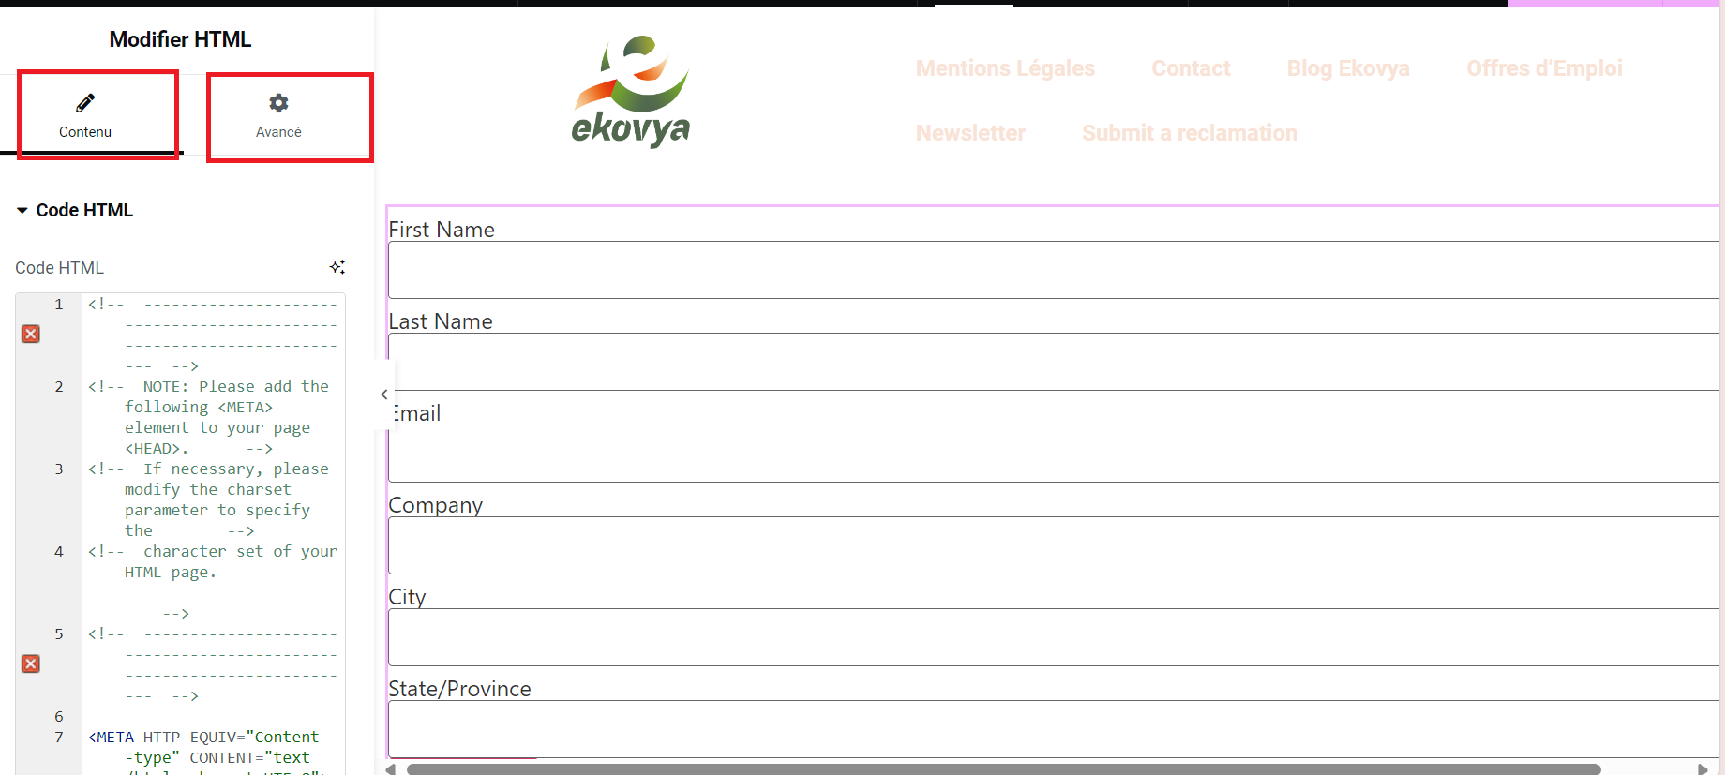

## 3. Scoring

## 1. Set up a validation rule

* Add fields

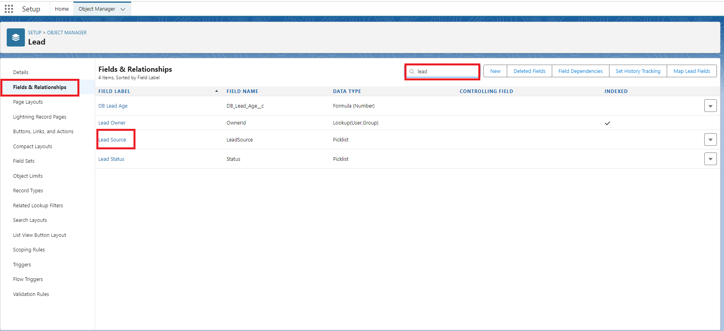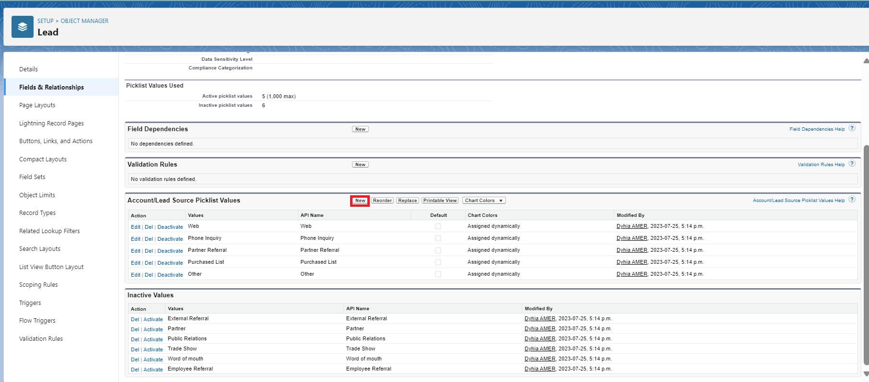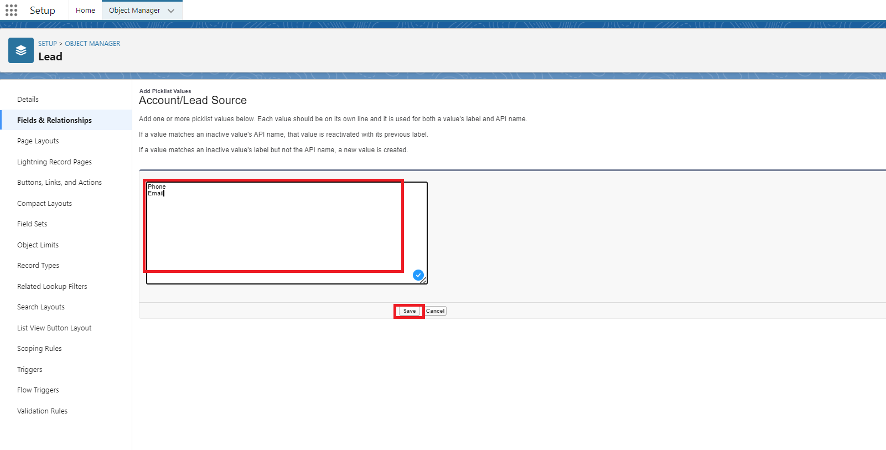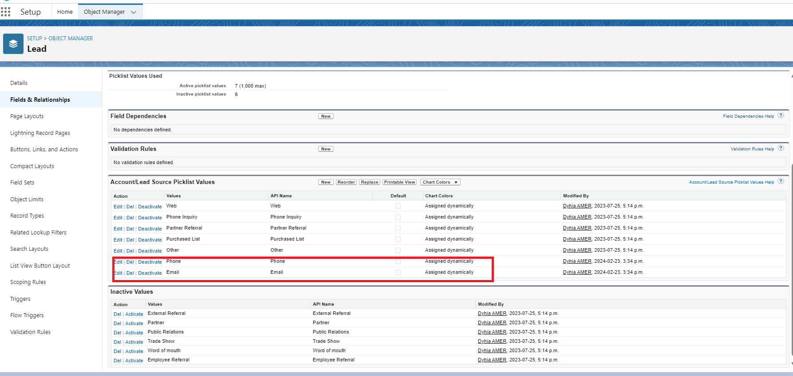

Set up the rule

